**Chocoholics Anonymous**



***Use Case Specification Document*** -

***05***

**Track Services**

**Version No. 1.0**

**Project Document Revision History**

|  |  |  |  |
| --- | --- | --- | --- |
| **VersionNumber** | **Date** | **Revision Author** | **Description of Revision** |
| 1 | 7/16/2019 | Zaid Alsafi | Initial version of use case 05 Track Services |

# 

|  |
| --- |
| **Table of Contents** |

[Introduction](https://docs.google.com/document/d/1hvfKWwgINM2WSLcX0g8zMjIdUDy5B4JiMRUBqk0b4MQ/edit#heading=h.gjdgxs) [4](https://docs.google.com/document/d/1hvfKWwgINM2WSLcX0g8zMjIdUDy5B4JiMRUBqk0b4MQ/edit#heading=h.gjdgxs)

[Use Case Information](https://docs.google.com/document/d/1hvfKWwgINM2WSLcX0g8zMjIdUDy5B4JiMRUBqk0b4MQ/edit#heading=h.30j0zll) [4](https://docs.google.com/document/d/1hvfKWwgINM2WSLcX0g8zMjIdUDy5B4JiMRUBqk0b4MQ/edit#heading=h.30j0zll)

[Actors](https://docs.google.com/document/d/1hvfKWwgINM2WSLcX0g8zMjIdUDy5B4JiMRUBqk0b4MQ/edit#heading=h.1fob9te) [4](https://docs.google.com/document/d/1hvfKWwgINM2WSLcX0g8zMjIdUDy5B4JiMRUBqk0b4MQ/edit#heading=h.1fob9te)

[Use Case Interaction](https://docs.google.com/document/d/1hvfKWwgINM2WSLcX0g8zMjIdUDy5B4JiMRUBqk0b4MQ/edit#heading=h.tyjcwt) [5](https://docs.google.com/document/d/1hvfKWwgINM2WSLcX0g8zMjIdUDy5B4JiMRUBqk0b4MQ/edit#heading=h.tyjcwt)

[Trigger](https://docs.google.com/document/d/1hvfKWwgINM2WSLcX0g8zMjIdUDy5B4JiMRUBqk0b4MQ/edit#heading=h.3dy6vkm) [5](https://docs.google.com/document/d/1hvfKWwgINM2WSLcX0g8zMjIdUDy5B4JiMRUBqk0b4MQ/edit#heading=h.3dy6vkm)

[Pre-condition(s)](https://docs.google.com/document/d/1hvfKWwgINM2WSLcX0g8zMjIdUDy5B4JiMRUBqk0b4MQ/edit#heading=h.4d34og8) [5](https://docs.google.com/document/d/1hvfKWwgINM2WSLcX0g8zMjIdUDy5B4JiMRUBqk0b4MQ/edit#heading=h.4d34og8)

[Post-condition(s)](https://docs.google.com/document/d/1hvfKWwgINM2WSLcX0g8zMjIdUDy5B4JiMRUBqk0b4MQ/edit#heading=h.17dp8vu) [6](https://docs.google.com/document/d/1hvfKWwgINM2WSLcX0g8zMjIdUDy5B4JiMRUBqk0b4MQ/edit#heading=h.17dp8vu)

[Use Case Swimlane (Activity) Diagram](https://docs.google.com/document/d/1hvfKWwgINM2WSLcX0g8zMjIdUDy5B4JiMRUBqk0b4MQ/edit#heading=h.lnxbz9) [6](https://docs.google.com/document/d/1hvfKWwgINM2WSLcX0g8zMjIdUDy5B4JiMRUBqk0b4MQ/edit#heading=h.lnxbz9)

[Main/Basic Flow(s) of Events (Happy Path)](https://docs.google.com/document/d/1hvfKWwgINM2WSLcX0g8zMjIdUDy5B4JiMRUBqk0b4MQ/edit#heading=h.35nkun2) [7](https://docs.google.com/document/d/1hvfKWwgINM2WSLcX0g8zMjIdUDy5B4JiMRUBqk0b4MQ/edit#heading=h.35nkun2)

[Alternate/Exception Flow of Events](https://docs.google.com/document/d/1hvfKWwgINM2WSLcX0g8zMjIdUDy5B4JiMRUBqk0b4MQ/edit#heading=h.1ksv4uv) [7](https://docs.google.com/document/d/1hvfKWwgINM2WSLcX0g8zMjIdUDy5B4JiMRUBqk0b4MQ/edit#heading=h.1ksv4uv)

[Assumptions/Business Rules including Non-Functional Requirements](https://docs.google.com/document/d/1hvfKWwgINM2WSLcX0g8zMjIdUDy5B4JiMRUBqk0b4MQ/edit#heading=h.44sinio) [7](https://docs.google.com/document/d/1hvfKWwgINM2WSLcX0g8zMjIdUDy5B4JiMRUBqk0b4MQ/edit#heading=h.44sinio)

[Use Case Specification Review and Signoff](https://docs.google.com/document/d/1hvfKWwgINM2WSLcX0g8zMjIdUDy5B4JiMRUBqk0b4MQ/edit#heading=h.2jxsxqh)[**7**](https://docs.google.com/document/d/1hvfKWwgINM2WSLcX0g8zMjIdUDy5B4JiMRUBqk0b4MQ/edit#heading=h.2jxsxqh)

# **Introduction**

When a member's card is swiped for a service that is being provided the system will track the current date and time, the service date that was provided, the providers number, member number, service code, and any comments that anyone entered.

# **Use Case Information**

An actor is someone or something (e.g. application system) outside the system or business that interacts with the application. For every Use Case, there must be at least one Main Actor and zero or more Secondary Actors. Actors should be a person, system, or time.

|  |  |  |
| --- | --- | --- |
| **Actor Name** | **Role** | **Description** |
| Member | Main | Tracks a members activity . |
| System | Main | It keeps a track of services provided and the fee details. |
| Provider | Main | Tracks on what a provider provides to members |

## **Use Case Interaction**

**Predecessors :**

Manage Members- use case ID-01 - A member must be registered with ChocAn Data Center and gets a member card to track the services provided by the Provider.

Member Payment -use case ID - 03 - The member payment reflects the current status of member in the system to keep track on members activities.

**Successors :**

Provider Payment - Use case ID-02 -The provider gets the payment based on the services provided by them for a week.

Report Extraction - use case ID - 04 - The provider and member reports gets generated on a weekly basis of the services and fees. Also, Manager extracts report at any time.

# **Trigger**

When a members card has been swiped or entered in the system for a service.

# **Pre-condition(s)**

Below are the pre-conditions which must be met before providing services:

* 1. A member must be registered with ChocAn Data Center to avail the services.
  2. A provider must be registered with ChocAn Data Center to provide services.

# **Post-condition(s)**

* 1. The Reports are generated on a weekly basis by the system.

# **Use Case Swimlane (Activity) Diagram**

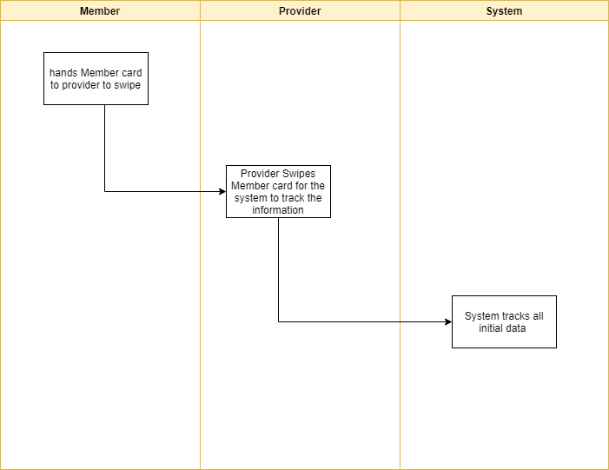

# **Main/Basic Flow(s) of Events (Happy Path)**

* 1. Tracks and saves data from the member and provider.

# **Alternate/Exception Flow of Events**

* 1. null data in the System.
  2. Data becomes Corrupted or was not able to be saved.

# **Assumptions/Business Rules including Non-Functional Requirements**

None.

# **Use Case Specification Review and Signoff**

|  |  |  |  |  |
| --- | --- | --- | --- | --- |
| **Review and Signoff of the Use Case Specification** | | | | |
| **Name** | **Project Team Role** | **Signature** | **Date** | |
|  |  |  |  | |
|  |  |  |  | |
|  |  |  |  | |
|  |  |  |  | |

# 